Space @ The Broomhouse Hub – South-West Edinburgh

Community Grants – Application Criteria

Who can apply?

Applications are invited from community groups, charities and voluntary organisations working in South-West Edinburgh (see map below).

Where a group is not constituted with at least two (non-related) signatories, we will consider applications from newly formed groups who are sponsored by other recognised constituted groups. (Sponsoring would involve another group/groups holding the allocated money for your idea with signed agreement between you both to provide funds when needed.)

In particular circumstances, we would consider sponsoring an idea—if you have any questions about this, please contact Space rather than being put off applying.

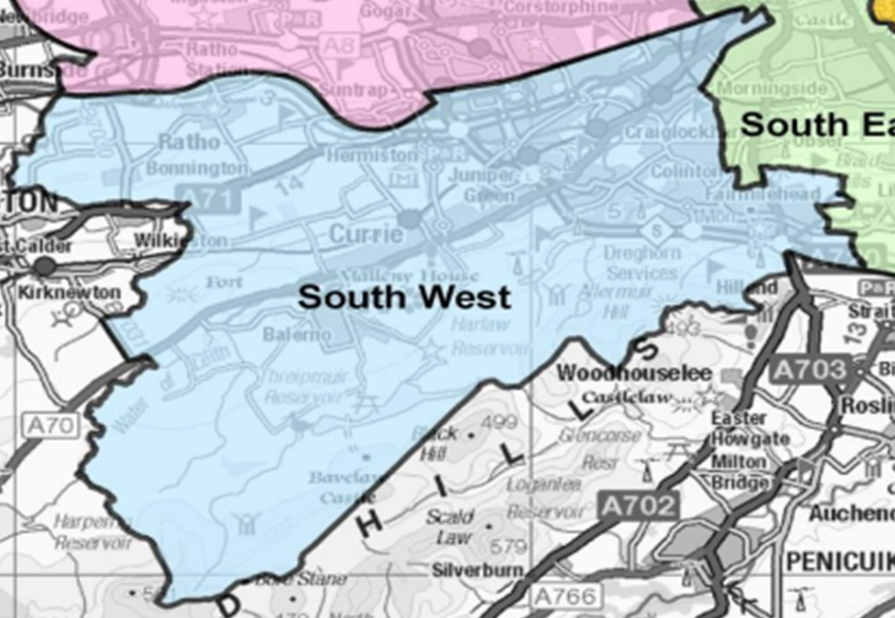

What funding is available?

We have £20,000 to disperse thanks to a generous donation from Baillie Gifford. Grants of up to £2,000 are available, but note we expect the average grant to be between £1,000 and £1,200.

Please do not manipulate your ask to fall just under these numbers; please build your idea and ask for the amount you require. These are guideline figures.

Please be aware that we may not be able to fully fund each project given the limited amount of funding available. We would encourage applicants to think about match funds or how a lower amount might affect the benefits you can deliver. We may, to ensure as many causes benefit as possible, choose to partially fund your project. If this is the case it will be clearly indicated.

What kinds of projects can be supported?

The project must fit in with one or more of the Integrated Community Fund priorities and the application should describe how you will meet this/these priorities:

- Reducing Social Isolation
- Improving Communication
- Employment Opportunities
- Supporting Families In Need
- Community Wellbeing

Funding will cover all reasonable expenses, including rent of a building, staff or volunteer costs as well as other overheads such as materials or refreshments.

Where possible, consider partnership working, especially if you are not a constituted group or do not have a bank account in the name of your group. We are keen to make the limited funds available go as far as possible and partnerships can be a great way to do this.

What is excluded?

Funds must be used to support the disparate communities of South West Edinburgh. As a result we would request that where possible, all funds are spent on services delivered within the area. This means we are unable to sponsor overseas trips. We are also unable to cover any costs for things like alcohol or any other harmful industry such as gambling.

Where possible we are looking for new ideas or ideas that support existing services. We do not want to replicate services that are already on offer locally. For example, Space provides support for young carers; however, a specific activity to benefit young carers would be considered.

We are also unable to make awards which include:

- Disbursement to other agencies (other than part of partnership working)
- General appeals
- Faith based activities
- Cash grants to individuals
- Capital spend on public buildings such as repairs to a school which are the responsibility of the local authority

Please do get in contact if you have any queries about the above.

Reporting

We will require a paragraph or two from you by 15th March 2024 detailing how you used the money to improve lives of people in the community. Supporting photos and quotes are encouraged. Please also record your project through pictures and/or videos.

We would be happy to support your project through our social media channels, too. Please tag Space @ The Broomhouse Hub on Facebook and Twitter.

Application details

Deadline for applications: 5 p.m. on 1st November 2023
Evaluation and voting process: 6th-17th November 2023
Applicants notified: 26th November 2023

Any grants awarded should ideally be spent by 29th February 2024
Final report due by 15th March 2024

Due to the resources available to us, we will not be able to provide in-depth feedback on unsuccessful applications.

Applications should be sent to: moreen.chebrot@spacescot.org
Our delivered to:
Space @ The Broomhouse Hub
79/89 Broomhouse Crescent
EH11 3RH

Please note: We do accept video applications.

Enquiries: Tel: 0131 455 7731
Email: moreen.chebrot@spacescot.org
Deadline for applications: 5 p.m. on 1st November 2023

DATA PROTECTION ACT
The information you provide will be input on computer. It will be used only to enable a decision to be made about whether a grant may be approved to your organisation.

Space @ The Broomhouse Hub (formerly The Broomhouse Centre), is a Registered Charity No, registered in Scotland SC003706, & Company Limited by Guarantee, registered in Scotland SC320027

